Detection of Child Predators Cyber Harassers on Social Media

In this project we are using various machine learning algorithms such as SVM, Random Forest, Naïve Bayes, KNearest Neighbours, and Decision Tree to predict child harasser’s posts from social networks.

Using all algorithms we will build train model with normal and harasser’s word and messages and this train model will applied on new posts from users to predict whether new post is normal or contain harasser’s stuff.

This project consists of following modules

User module: using this module users can create an account. Using account details they can login to application and then send and view posts.

Admin Module: Admin can view all registered user account and then accept or reject new user account. Admin responsible to add new harasser/non-harasser messages to machine learning train dataset. Admin has to run all or at-least one SVM algorithm to perform harasser’s message detection from user side. Admin can view or monitor all posts send by all users.

Note: machine learning algorithms will predict harasser’s or normal message if only some related data available in train model. So you can predict all those messages correctly which are entered by admin. All sample normal and harasser’s messages are available inside ‘Cyber/dataset.txt’ file.

First create database by copying content from ‘DB.txt’ file and paste in MYSQL console

To run this project install DJANGO and then deploy ‘Cyber’ folder in DJANGO and start server and run in browser by entering URL as ‘<http://127.0.0.1:8000/index.html>’. After running above URL will get below screen

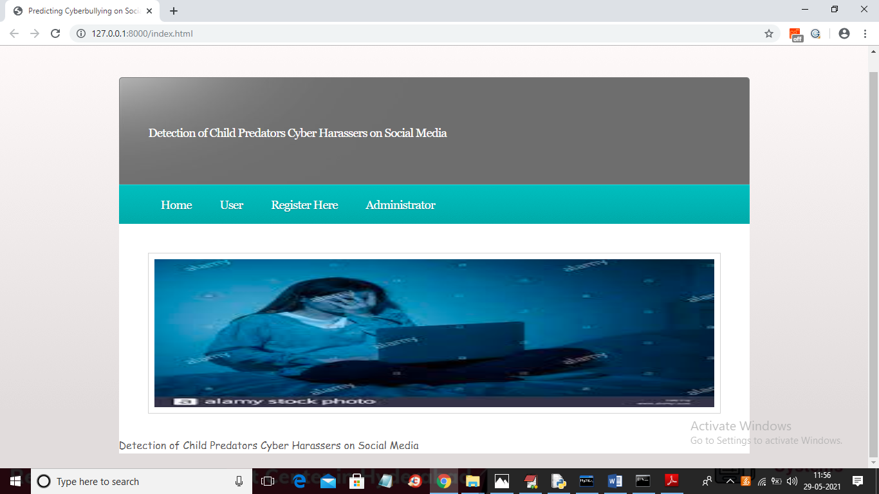

In above screen click on ‘Register Here’ link and add new user to create account

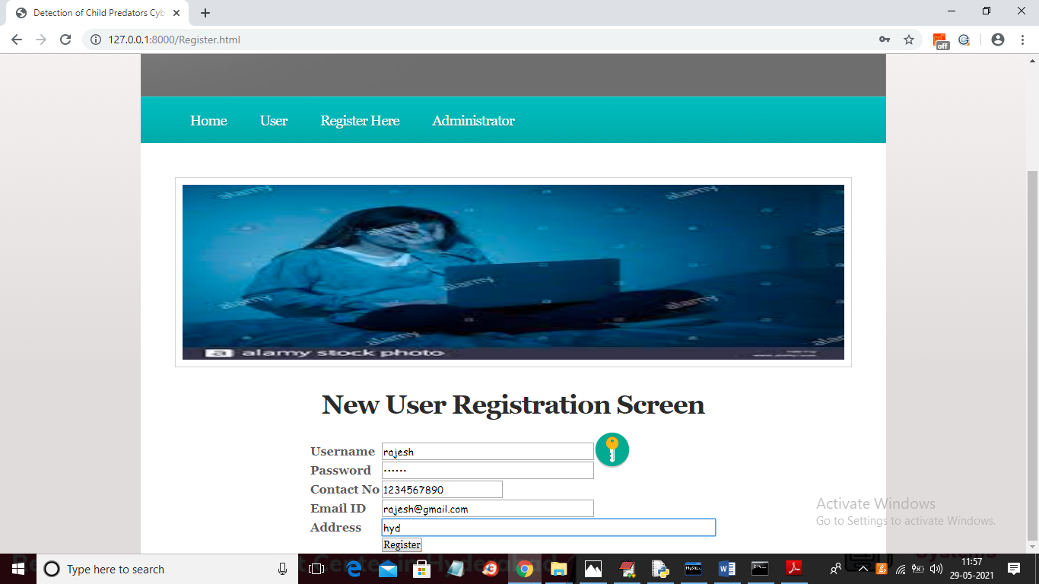

In above screen now click on ‘Register’ button to add details

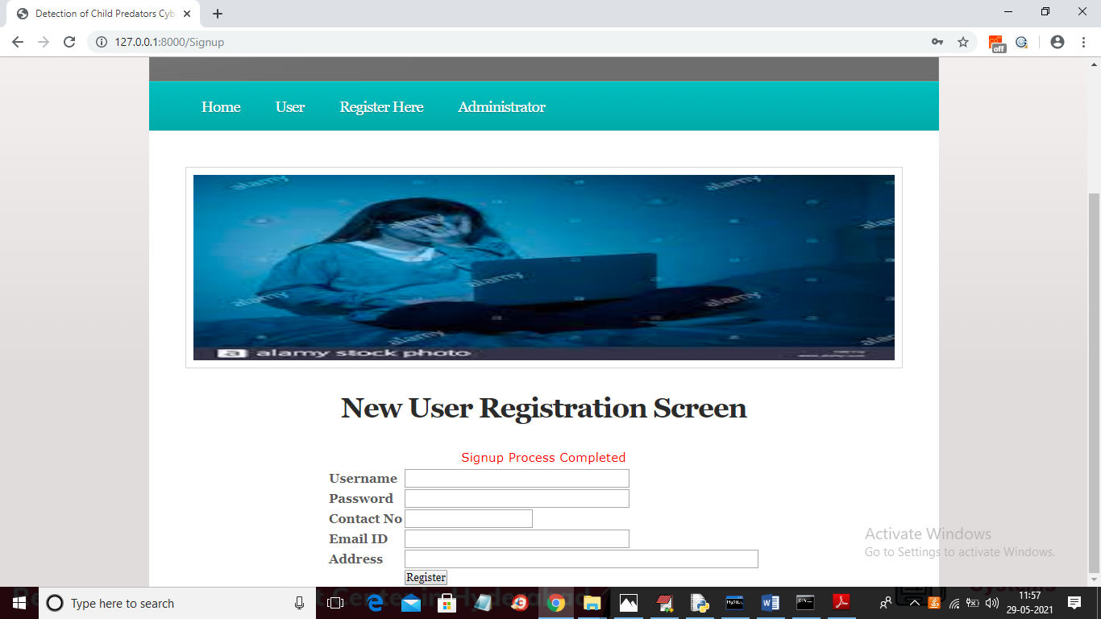

In above screen sign up process completed. Now click on ‘Administrator’ link to login as admin view new user details

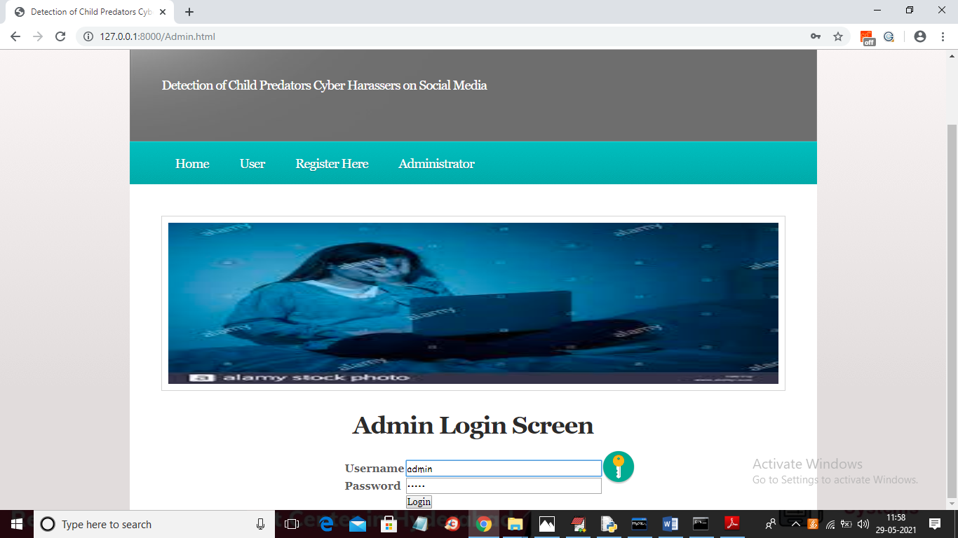

In above screen login as ‘admin’ by giving username as ‘admin’ and password as ‘admin’. After login will get below screen



Now admin can click on ‘View Users’ link to view all users list

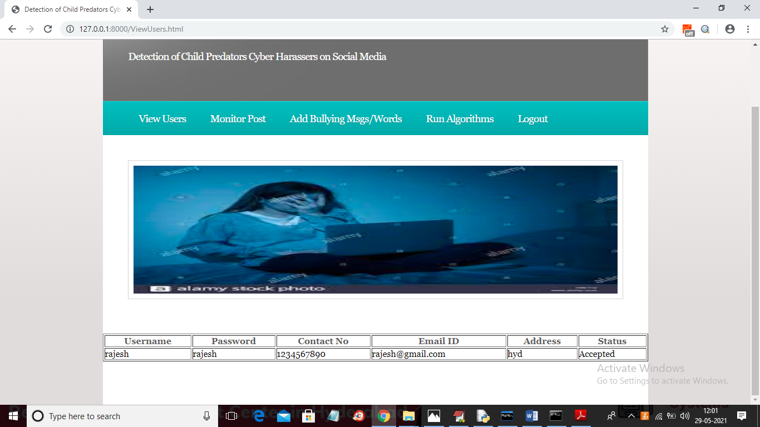

In above screen we can see ‘rajesh’ account created. . Now admin can click on ‘Monitor Post’ to view all post from past users

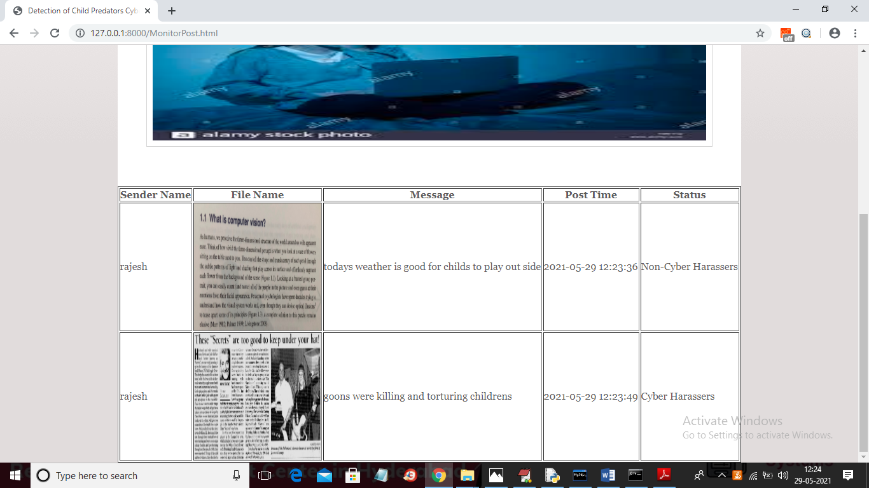

In above screen application will automatically detect whether message is non-cyber harasser’s or harassers from machine learning algorithms. Now admin can click on ‘Add Bullying Msgs/words’ link to add words

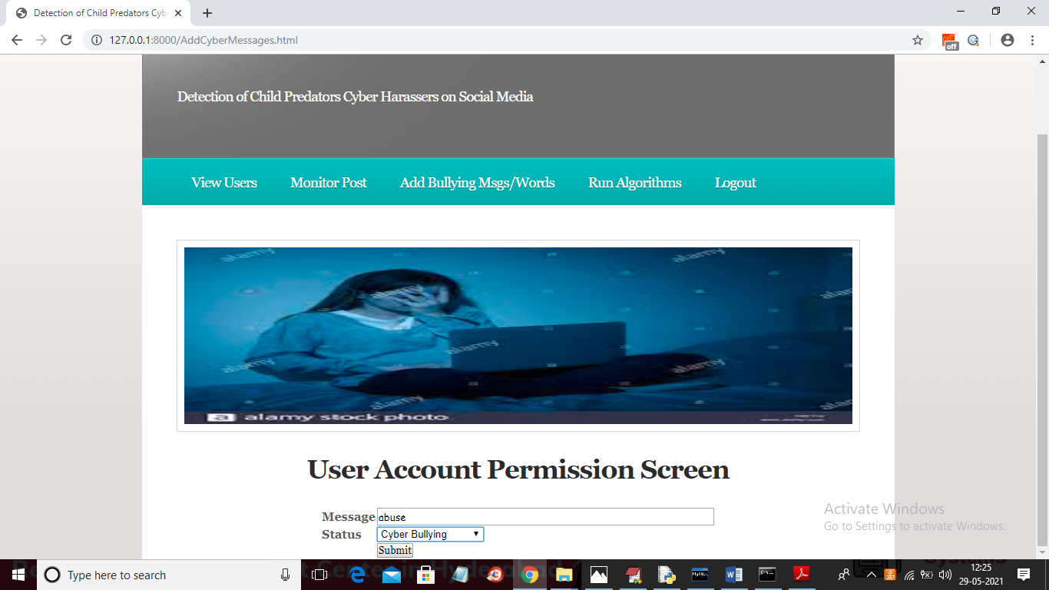

In above screen admin adding one word as ‘Cyber Bullying’ and similarly he can add all possible bullying and non-bullying messages. After adding messages will get below screen

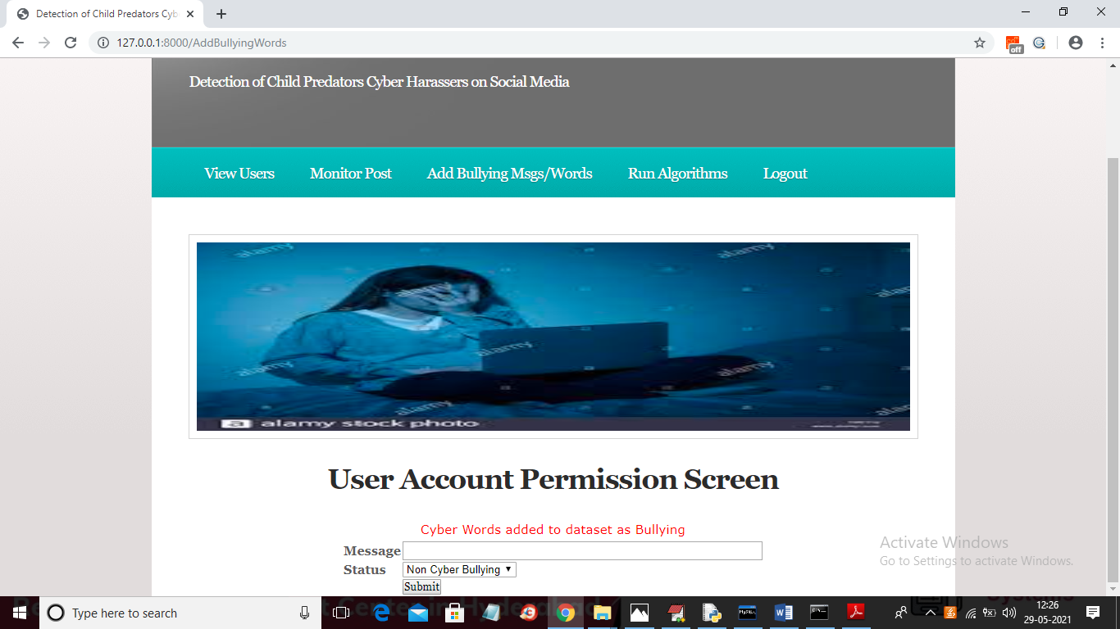

Now admin can click on ‘Run Algorithms’ link to generate train model using entire dataset to predict user posts as normal or bullying/harasser’s

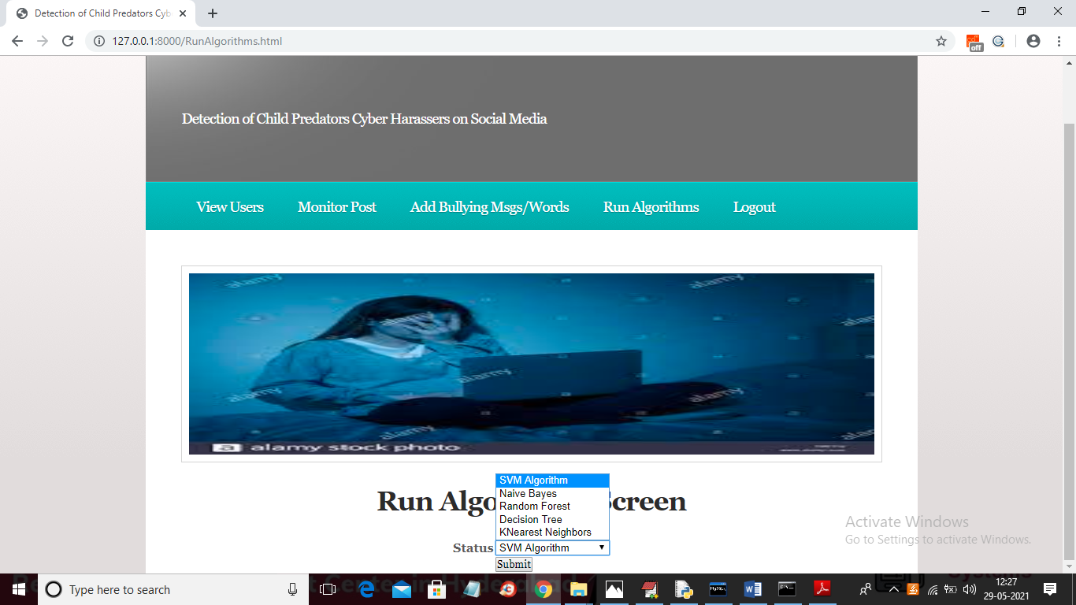

In above screen admin has to select each algorithm and click on ‘Submit’ button to train model and we will get accuracy also for each algorithm. Admin has to repeat this step whenever first time he starts the server or upon adding new bulling messages. Admin has to run at least SVM algorithm to perform automatic detection of harasser’s or non-harasser’s

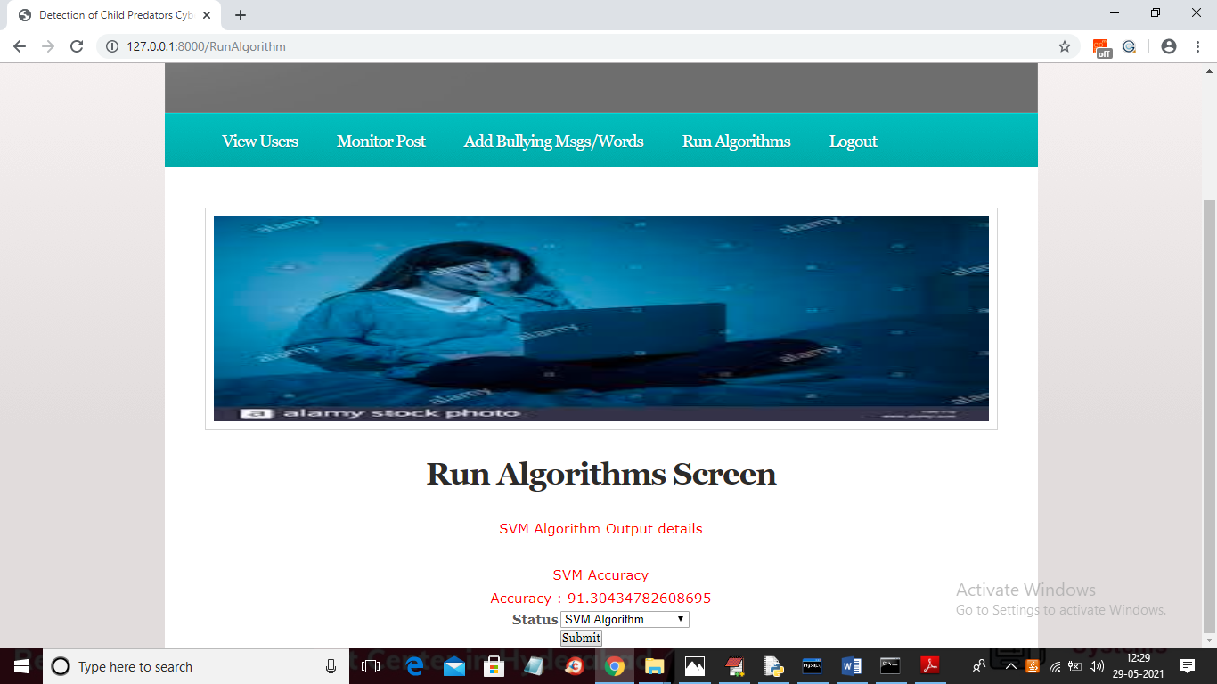

In above screen I ran SVM and got accuracy as 91. Similarly u need to select all algorithms one by one and run it.

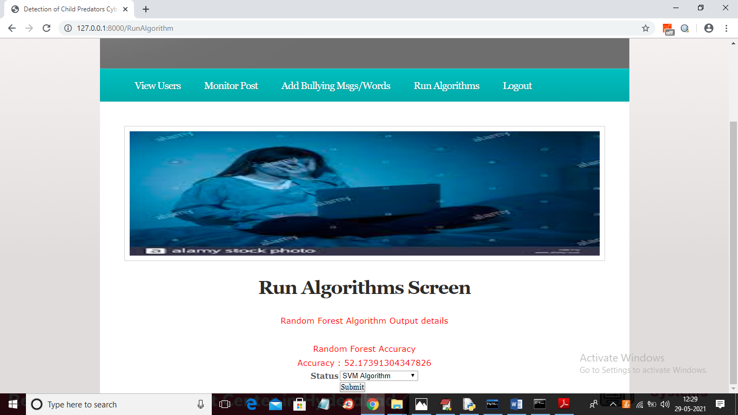

In above screen advance ‘Random Forest’ algorithm gave 52% accuracy. Now admin logout and login as user to send posts.

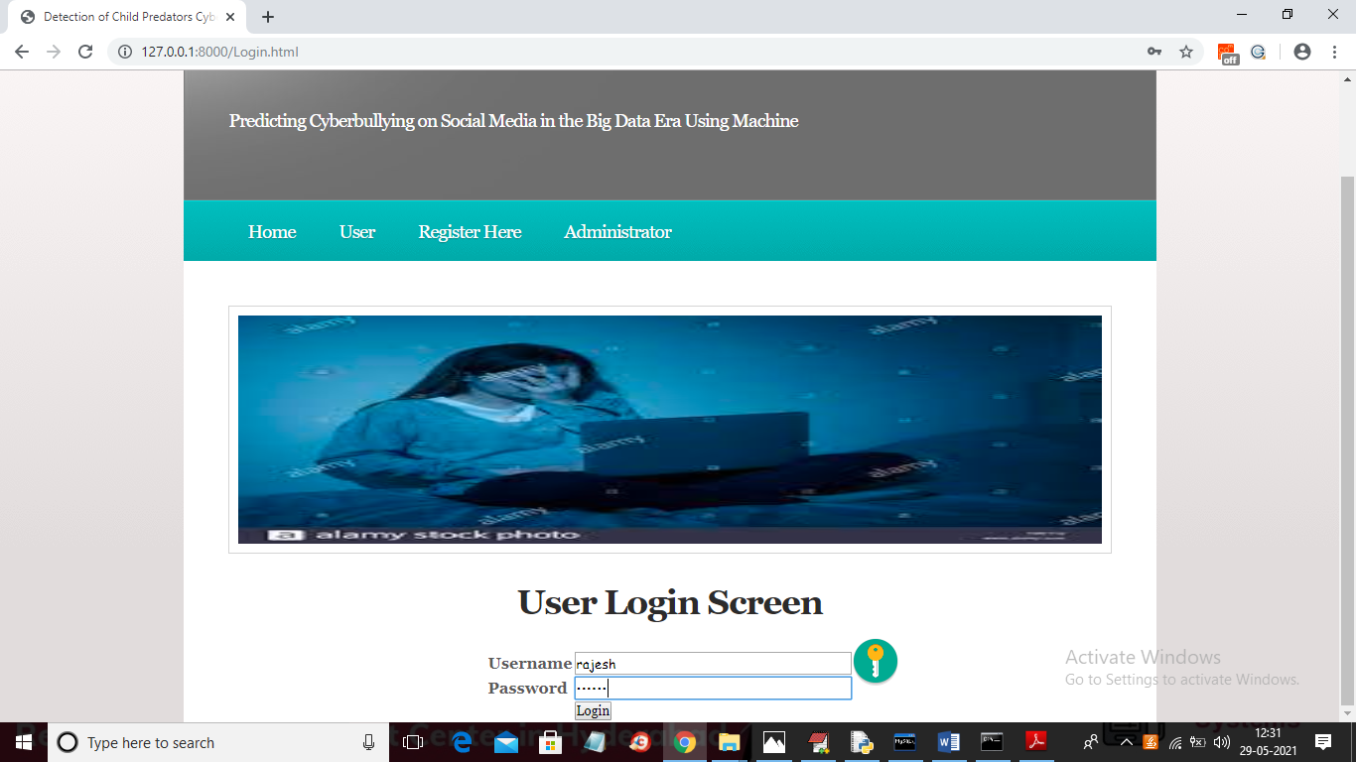

In above screen rajesh user is login and after login will get below screen



In above screen click on ‘Send Post’ link to get below screen

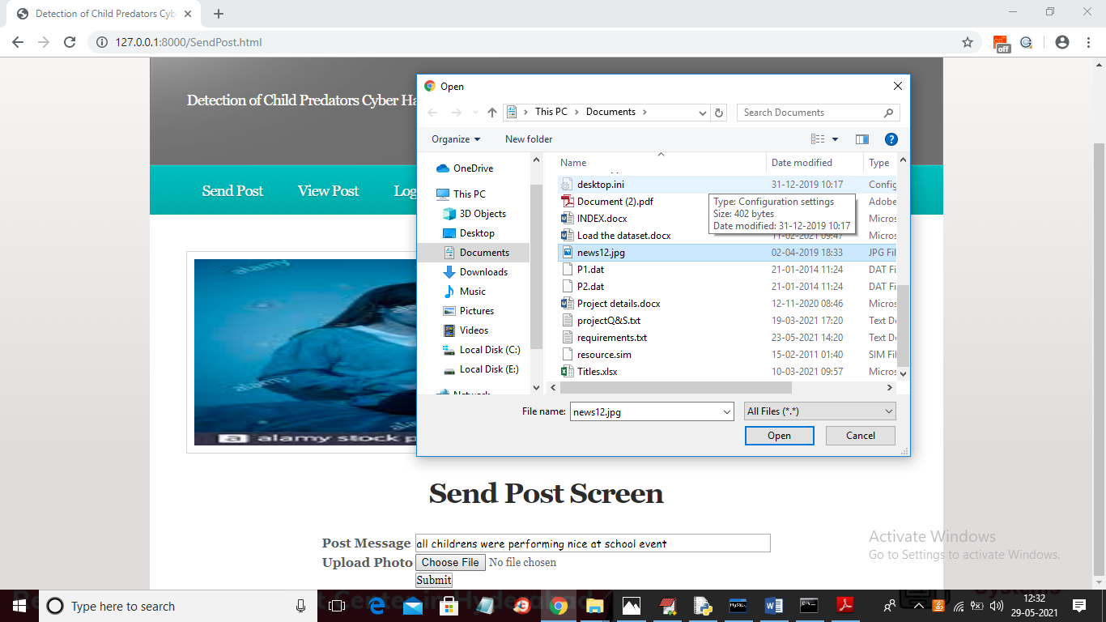

In above screen as post I added some messages and uploaded a photo also. After posting message will get below screen

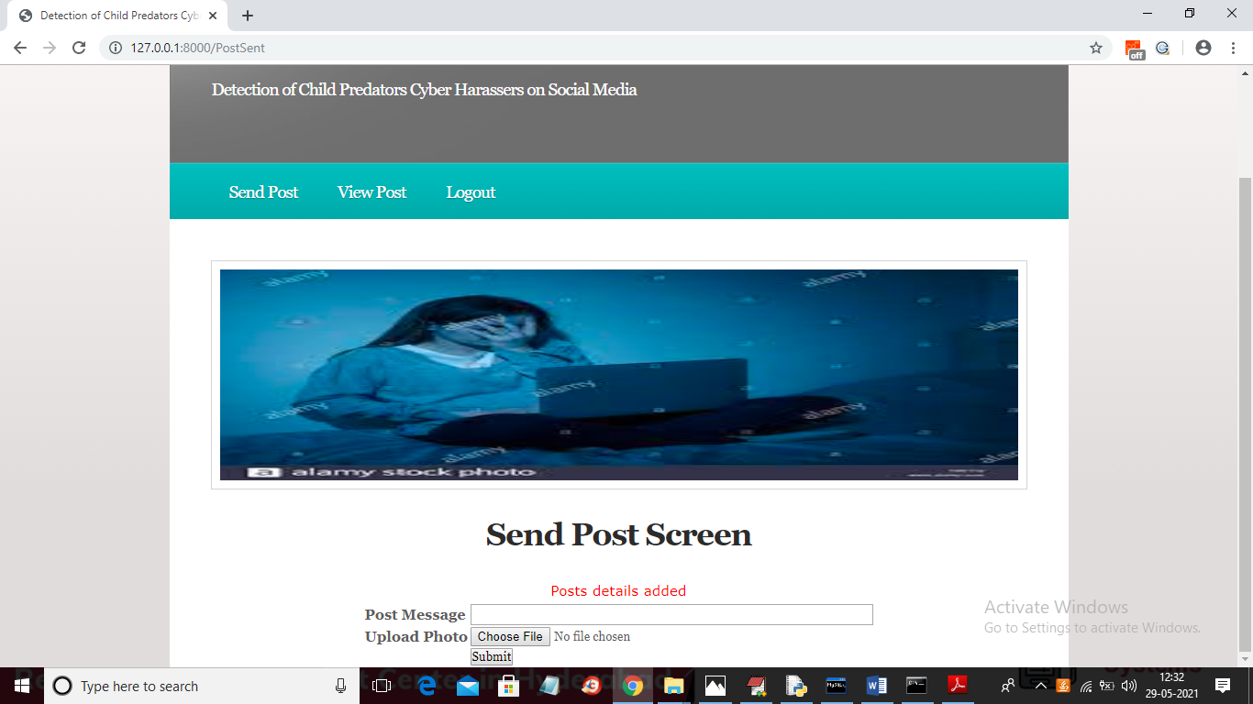

Now try another message

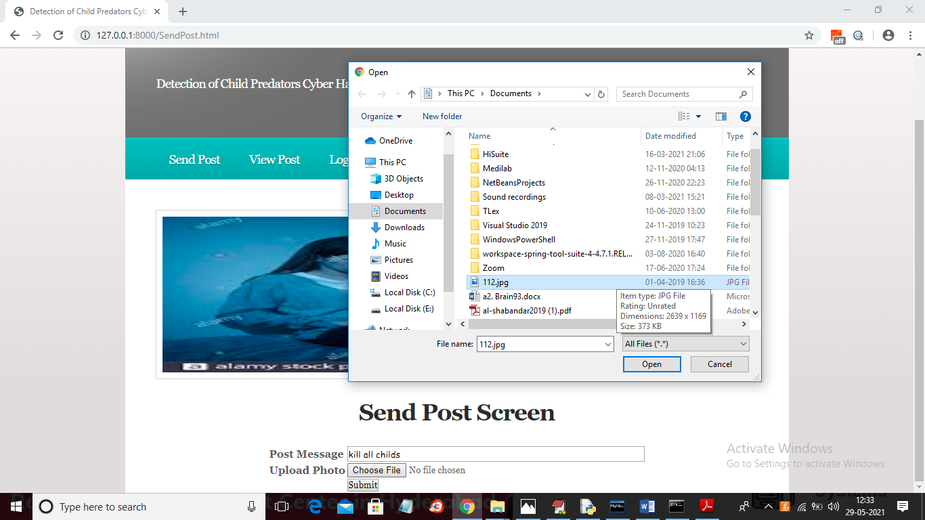

In above screen added another message and now click on ‘View Post’ link to get all posts sent by users

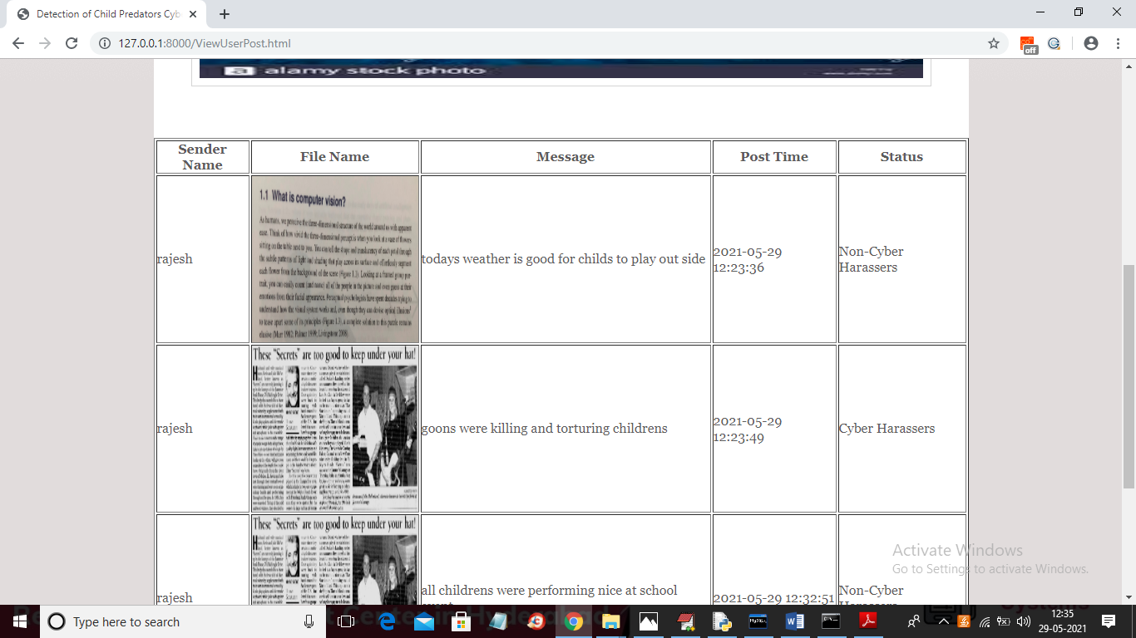

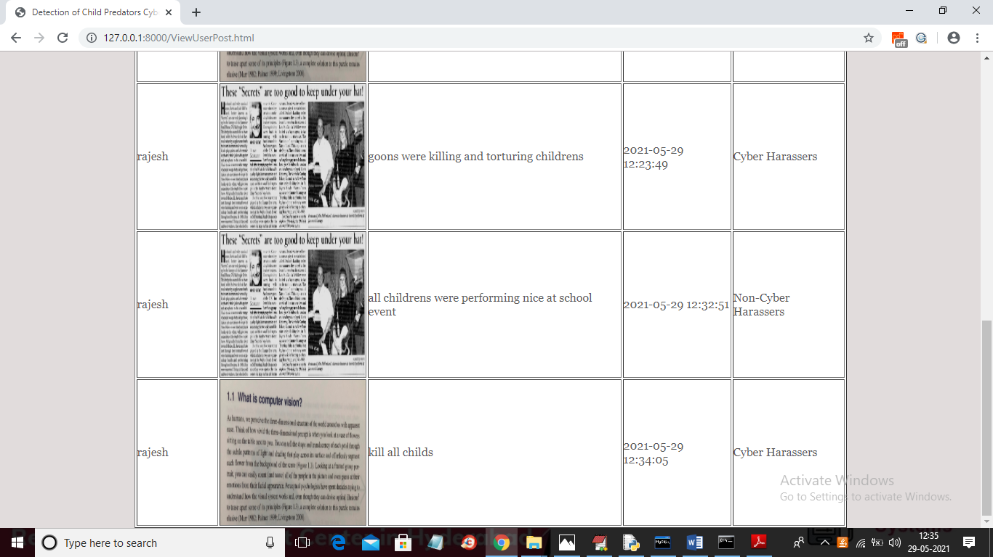

In above screen we are seeing posts from all users and we can see with the help of machine learning SVM algorithms we are automatically able predict message as cyber or non-cyber harasser’s. Similarly you can signup new users and then post new messages.

Machine learning will predict harasser or non-harasser word based on dataset records so you add all possible harasser and non-harasser words to dataset by using ‘add words’ module from admin. After adding words then run algorithms link to train model and then you can see application will predict harasser or non-harasser automatically.

Note: before running code change your system directory in views.py

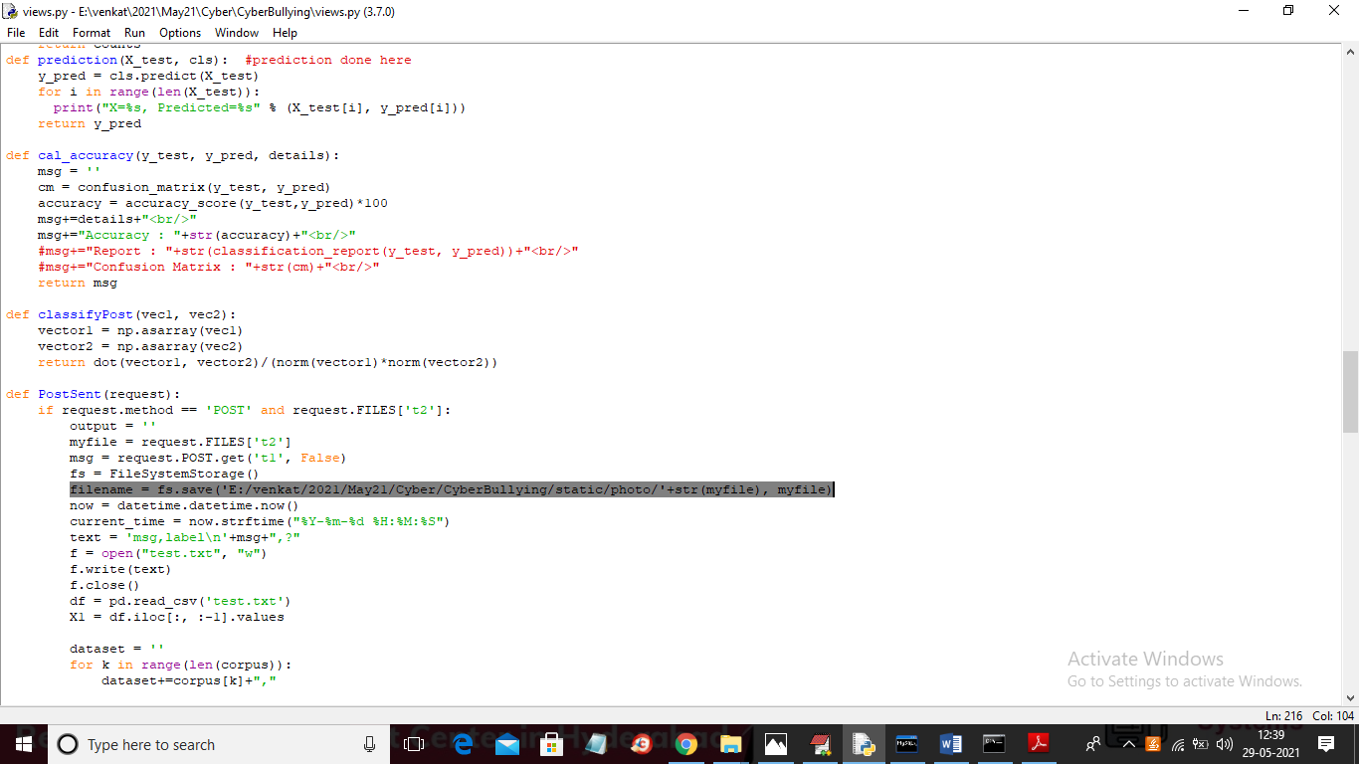

Change above selected line with your system directory